From: https://www.mintpressnews.com/us-backed-fascist-azov-battalion-in-ukraine-is-training-and-radicalizing-american-white-supremacists/251951/?fbclid=IwAR1sH3iPTTBFlW4NU7RtjRxTCrcE-htdEdW6f8ZCPXHNE_Ky-ZVcbPIpIOc

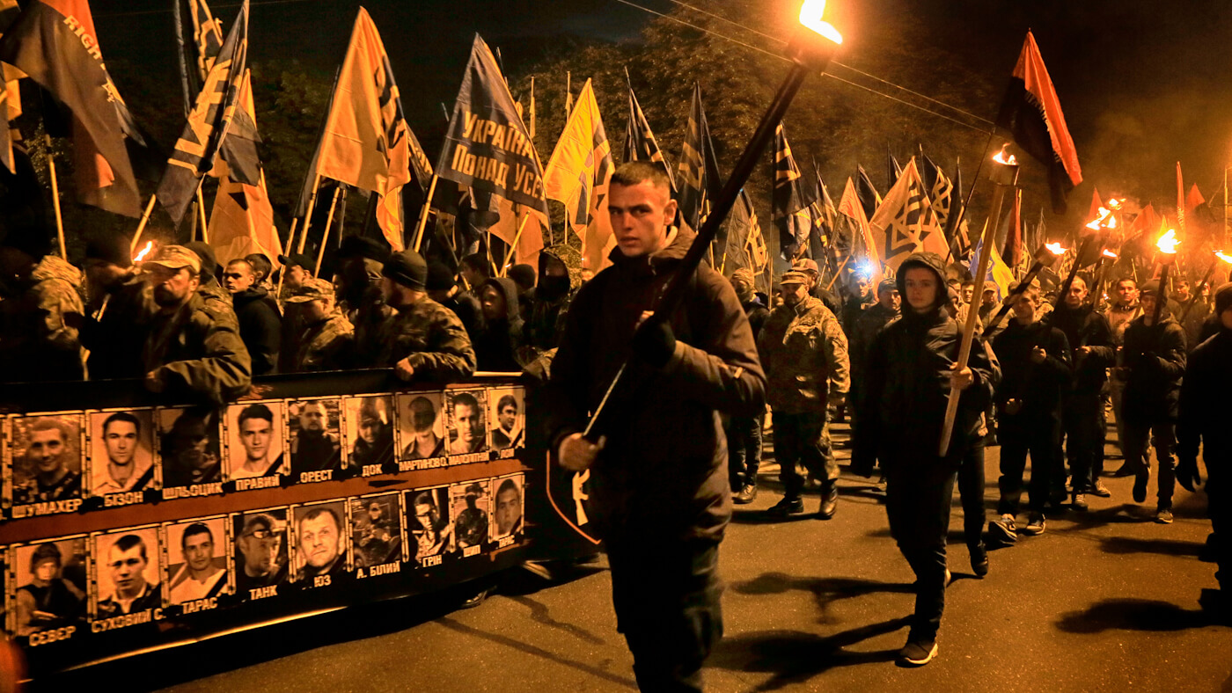

FROM MAIDAN TO MAIN STREET
Blowback: An Inside Look at How US-Funded Fascists in Ukraine Mentor US White Supremacists
Not only are white supremacists from across the West flocking to Ukraine to learn from the combat experience of their fascist brothers-in-arms, they are doing so openly, under the nose of a shrugging law enforcement — chronicling their experiences on social media before they bring their lessons back home.

by Max Blumenthal

November 19th, 2018
By Max Blumenthal
18 Comments
FacebookTwitterRedditEmailMore5K
Last month, an unsealed FBI indictment of four American white supremacists from the Rise Above Movement (RAM) declared that the defendants had trained with Ukraine’s Azov Battalion, a neo-Nazi militia officially incorporated into the country’s national guard. The training took place after the white supremacist gang participated in violent riots in Huntington Beach and Berkeley, California and Charlottesville, Virginia in 2017.
The indictment stated that the Azov Battalion “is believed to have participated in training and radicalizing United States-based white supremacy organizations.”
After a wave of racist violence across America that culminated in the massacre of twelve Jewish worshippers at a Pittsburgh synagogue, the revelation that violent white supremacists have been traveling abroad for training and ideological indoctrination with a well-armed neo-Nazi militia should cause extreme alarm.


Not only are white supremacists from across the West flocking to Ukraine to learn from the combat experience of their fascist brothers-in-arms, they are doing so openly — chronicling their experiences on social media before they bring their lessons back home. But U.S. law enforcement has done nothing so far to restrict the flow of right-wing American extremists to Azov’s bases.
There is one likely explanation for the U.S. government’s hands-off approach to Azov recruitment: the extremist militia is fighting pro-Russian separatists as a front-line proxy of Washington. In fact, the United States has directly armed the Azov Battalion, forking over anti-tank rocket launchers and even sending a team of Army officers to meet in the field with Azov commanders in 2017.
Though Congress passed legislation this year forbidding military aid to Azov on the grounds of its white supremacist ideology, the Trump administration’s authorization of $200 million in offensive weaponry and aid to the Ukrainian military makes it likely new stores of weapons will wind up the extremist regiment’s hands. When queried by reporters about evidence of American military training of Azov personnel, multiple U.S. army spokespersons admitted there was no mechanism in place to prevent that from happening.
Today, Azov boasts combat experience, unlimited access to light weapons, and supporters honeycombed throughout the upper echelons of Ukraine’s military and government. No longer just a militia, the organization has developed into a political juggernaut that can overpower Ukraine’s government. Two years ago, the group flexed its muscle on the streets of Kiev, bringing out 10,000 supporters to demand that the government bend to their will or face a coup.
“With its military experience and weapons, Azov has the ability to blackmail the government and defend themselves politically against any opposition. They openly say that if the government will not advance an ideology similar to theirs, they will overthrow it,” Ivan Katchanovski, a professor of political science at the University of Ottawa and leading expert on Ukraine’s far-right, commented to me. He continued, explaining:
Currently the organizations that are fascist are stronger in Ukraine than in any other country in the world. But this fact is not reported by Western media because they see these organizations as supportive of the geopolitical agenda against Russia. So condemnations are limited to violence or human rights abuses.”
The revelations of collaboration between violent American white supremacists and a neo-Nazi militia armed by the Pentagon add another scandalous chapter to a long history of blowback that dates back to the 1950’s, when the CIA rehabilitated several Ukrainian Nazi collaborators as anti-communist assets in the Cold War.
The almost unbelievable story exposes an axis of fascism that stretches across the Atlantic, from the Ukrainian capital of Kiev to the sun-washed suburbs of Southern California, where some of the most rabid modern white supremacist gangs were born.

The white nationalist Fight Club
This October, four members of the RAM gang — Robert Rundo, Benjamin Drake Daley, Michael Paul Mirelis, and Aaron Eason — were arrested by FBI agents. They were accused of “using the internet to encourage, promote, participate in, and carry out riots” from Huntington Beach to Berkeley, California. Four other members had been arrested in connection with their participation in the white supremacist riot in Charlottesville, Virginia, where a counter-protester, Heather Heyer, was killed in a vehicular homicide by a white supremacist.
RAM first appeared in the national limelight during a celebration of Donald Trump’s election victory in Huntington Beach in March 2017. As about one hundred far-right activists marched along the beach donned in red “Make America Great Again” caps and waving Trump flags, they were confronted by a small group of masked anti-racist counter-demonstrators. When a melee ensued, RAM members assaulted their outnumbered opponents, pummeling them into submission and even attacking a local reporter. Afterwards, Orange County police arrested several anti-racist demonstrators, but the RAM gang walked free.
RAM markets itself as a self-defense organization that protects the free speech of white Americans against an onslaught of “Cultural Marxism,” a classic anti-Semitic trope. Its founders emphasize a vaguely anti-consumerist Fight Club mentality along with a rigorous dedication to mixed martial arts. Its co-founder, Rundo, operates an online clothing and apparel company, Right Brand Clothing, that hawks slickly designed t-shirts promoting “European Brotherhood,” stickers emphasizing a straight-edge “nationalist lifestyle,” and ethically sourced designer “Demagogue pants” (yes, white supremacists apparently care about sweatshops). RAM members can be seen at the site modeling their gear with a clean-cut “fashy” look that contrasts sharply with the stereotypical image of skinheads in jackboots.
RAM’s careful attention to its public image has not stopped its members from putting their crude neo-Nazi ideology on display at rallies, however. During the Huntington Beach riot, for example, RAM’s Robert Boman was seen waving a sign reading “Da Goyim Know.” This alt-right slogan refers to the white nationalist understanding of the supposed Jewish plot to dominate the world.
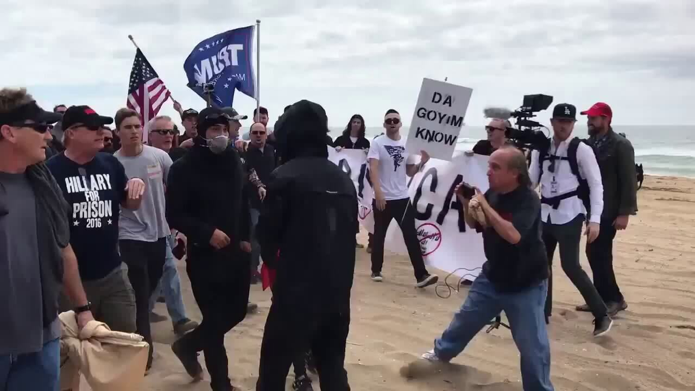
Screenshot | YouTube
“I’m a big supporter of the Fourteen, I’ll say that,” RAM’s Rundo proclaimed into a camera in Huntington Beach. The gang leader was referring to the notorious 14-word slogan coined by convicted white supremacist terrorist David Lane, which has become a rallying cry for fascists across the globe: “We must secure the existence of our people and a future for white children.”
Two months after the violence in Huntington Beach, two RAM members were photographed in the same spot dousing literature they dubbed as “Cultural Marxist” with lighter fluid and setting it ablaze. Among the volumes they torched were
- “The Diary of Anne Frank,”
- “The 9/11 Commission Report,” and
- “Schindler’s List.”
Besides evoking memories of the early days of Nazi Germany, the spectacle cast the group’s purported devotion to free speech in an extremely ironic light.
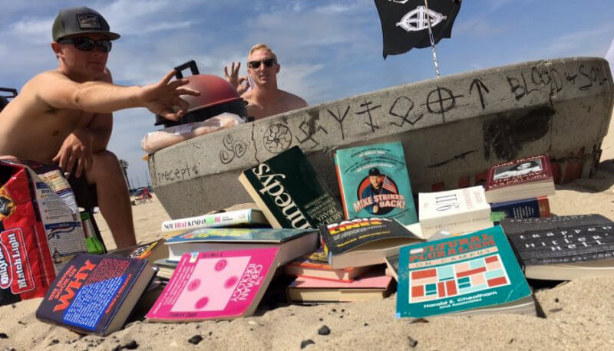
Photo | Northern California Anti-Racist Action
Following RAM’s highly publicized street battles, the group became the subject of intense media scrutiny. In October 2017, the investigative outlet ProPublica produced a videothat exposed the identities of RAM’s core membership and wondered why they had not been investigated by law enforcement for their violent actions in Huntington Beach and elsewhere.
But the media coverage of RAM glossed over the group’s attraction to a burgeoning trans-Atlantic conglomeration of white supremacists that centered on U.S.-allied Ukraine as the base for a fascist reconquest of Europe. By the Spring of 2018, RAM leadership was barnstorming through Germany and Italy and heading east to meet fascist cohorts from across the West at a conference in Kiev.

RAM’s Ukrainian hate-cation
Buried in the FBI indictment of RAM members are details of their meetings with one of the key figures in Ukraine’s neo-Nazi Azov Battalion militia.
In August, according to the indictment, RAM members published photos on Instagram showing themselves meeting with Olena Semanyaka, the leader of the international department of the Ukrainian National Corps, which functions as a civilian arm of the Azov Battalion:
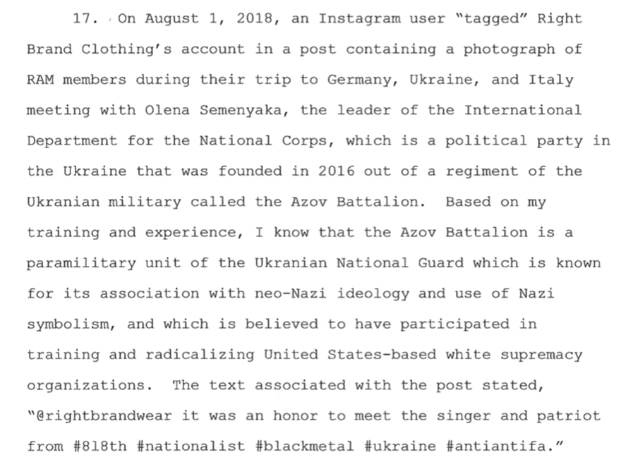
The indictment also referenced a video of RAM co-founder Benjamin Drake Daley performing a crossed-forearm salute to the Southern California-based white supremacist Hammerskin gang while in Ukraine:
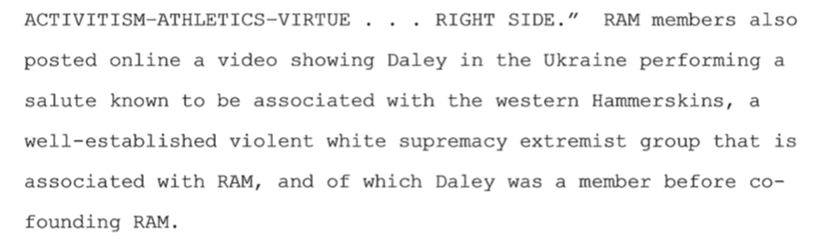
RAM’s Gab account provides additional details of the group’s foray through Ukraine this May. The trip centered around the Paneuropa conference, an event that brings together fascists from across the West to encourage international collaboration. It is hosted at the Reconquista Club in Kiev, and included an MMA competition.
“One of our guys has had the honor to be the first American to compete in the pan european organization Reconquista in Ukraine!” RAM declared on its Gab account. “This was a great experience meeting nationalist[s] that came [sic] as far as Portugal and Switzerland to take part.”
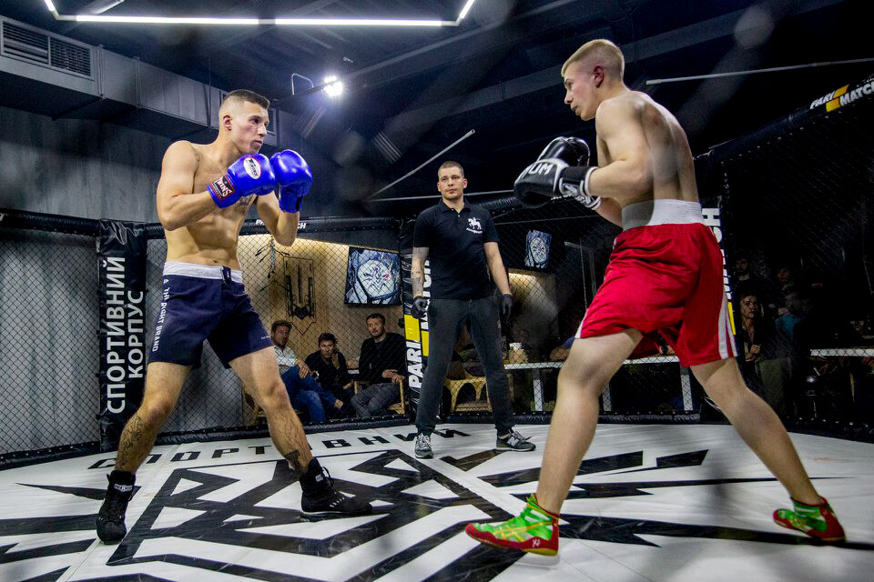
Robert Rundo, left, of the Rise Above Movement competes at Azov’s Reconquista Club in Kiev, Ukraine. Photo | Gab
The visit, which followed on the heels of meetings with white supremacists in Germany and with Italy’s fascist CasaPound party, highlighted the centrality of Ukraine to international fascist organizing. Further, the Paneuropa conference, where fascists build connections across national borders, revealed the Azov Battalion as much more than a militia fighting for control of a sliver of contested territory in eastern Ukraine.
Semanyaka did not respond to an interview request delivered through Facebook messenger; however, she told Radio Free Europe’s Christopher Miller that RAM “came to learn our ways” and showed interest in learning how to create youth forces in the way Azov has.
Today, Azov leaders openly acknowledge that were it not for the U.S.-backed coup that unfolded in Kiev’s Maidan Square in 2014, their organization would never have developed into the powerhouse it is. As Semanyaka said this year, according to a summary:
The Ukrainian nationalist movement would have never reached such a level of development unless the war with Russia had begun. For the first time since the Second World War, nationalist formations have managed to create their own military wings, the brightest example being the Azov regime of the National Guard of Ukraine.”

The right-wing revolution on the Maidan
The 2013-14 Maidan revolt was the cataclysmic event that Ukraine’s already potent ultra-nationalist camp had been waiting for. The protests erupted in Kiev’s Maidan Square after the democratically elected President Viktor Yanukovych refused to sign an economic association agreement with the EU. Celebrated in the West as a pro-Western movement guided by tech-savvy middle-class youth, EuroMaidan depended heavily for its success on phalanxes of black-masked hardmen from Right Sector (see appendix at bottom), an ultra-nationalist party that did battle with the government’s Berkut riot police.
Along with Right Sector, the leadership of the far-right Svoboda Party assumed a prominent role at the Maidan, dubbing the protests a “Revolution of Dignity.” Svoboda co-founder Oleh Tyahnybok — who had once demanded an investigation of the “Jewish-Muscovite mafia” that he saw controlling Ukraine — appeared on stage at the square beside U.S. Senators John McCain and Chris Murphy when they arrived to encourage the protesters.
Another key figure in Ukraine’s neo-Nazi scene was Andriy Biletsky. A university Ph.D. who stressed physical violence as a means to revolutionary change, Biletsky led the Patriot of Ukraine militia, an early forerunner of Azov that attacked migrant camps and menaced foreigners. In a manifesto published during the height of the Maidan clashes, Biletsky outlined his post-revolutionary agenda: “The historic mission of our nation in this critical moment is to lead the White Races of the world in a final crusade for their survival,” he wrote. “A crusade against the Semite-led Untermenschen.”
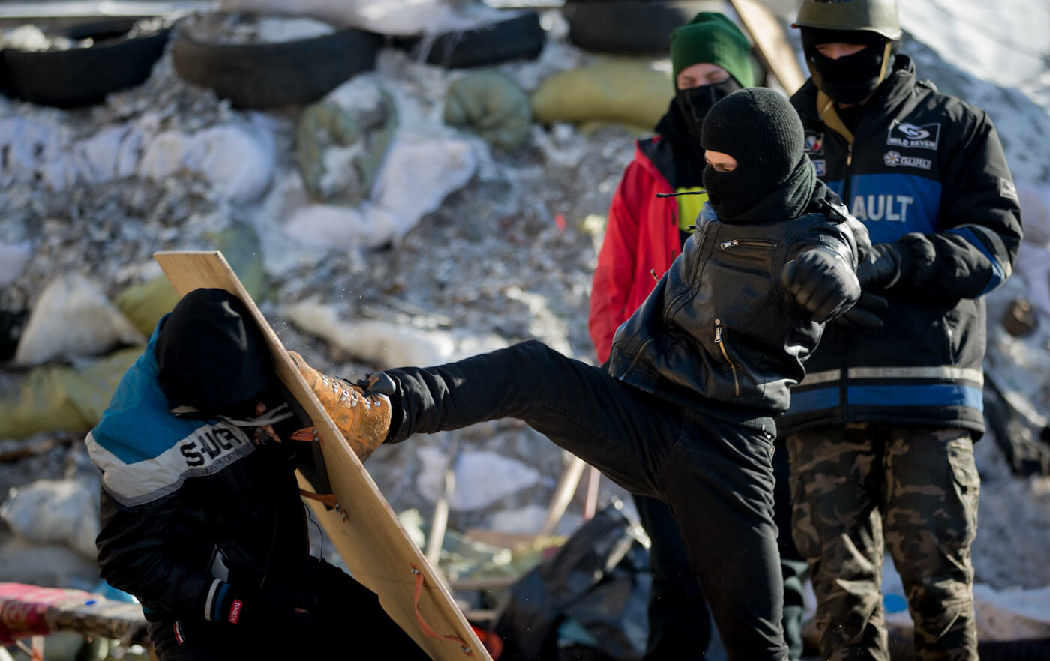
Members of the Right Sector practice street fighting in central Kiev, Ukraine, Feb. 3, 2014. Darko Bandic | AP
In May 2014, Right Sector and an assortment of far-right forces banded together to massacre their opponents in Odessa, attacking a pro-separatist protest camp with iron pipes then burning the fleeing protesters alive after they took shelter in a local trade union building. Over 40 pro-separatist Ukrainian citizens were consumed in the flames. The U.S. and EU studiously looked the other way, legitimizing the violence and setting the stage for more.
Behind the scenes, U.S. Assistant Secretary of State Victoria Nuland and Ambassador Geoffrey Pyatt were carefully stage managing the opposition, positioning the pliable Arseniy Yatsenyuk as the future leader of a U.S. client-state. Meanwhile, billionaire-backed U.S. soft-power entities like the Omidyar Network and Open Society Foundation plowed money into the opposition, providing it with high-tech organizing capacity and establishing new media outlet Hromadske overnight.
Given the amount of U.S. investment in regime change in Ukraine, it was necessary for American pundits who cheered on the operation to downplay or simply deny the central role neo-Nazi forces played in making it all possible. In perhaps the most absurd attempt at whitewashing the fascist presence, the neoconservative pundit James Kirchick described Right Sector in an article for Foreign Affairs as “Putin’s imaginary Nazis.” Meanwhile, groups like the Anti-Defamation League — which supposedly exist to battle anti-Semitism — refused to support a congressional effort to ban arms to groups affiliated with Right Sector, because “the focus should be on Russia.”
With all the cover he needed from Washington, Biletsky organized the “imaginary Nazis” of Patriot of Ukraine, Right Sector, and assorted football ultras into a real militia called the Azov Battalion. Together, they fought under the neo-Nazi Wolfsangel symbol, which also happens to be incorporated into the logo of the U.S.-based Aryan Nations.
On the frontlines of eastern Ukrainian flashpoints, Azov did battle with Russian-speaking separatists and set up government-sponsored indoctrination camps for children and teens closer to the country’s interior, instructing ten year olds on marksmanship and the evils of foreigners. Azan was subsequently absorbed into Ukraine’s military as a national guard unit, and began appearing in the field with PSRL-1 rocket launchers supplied under the watch of the U.S. Department of Defense. In November 2017, Azov leadership received a team of U.S. Army officers for training and logistical discussions (see photo below and to the right).
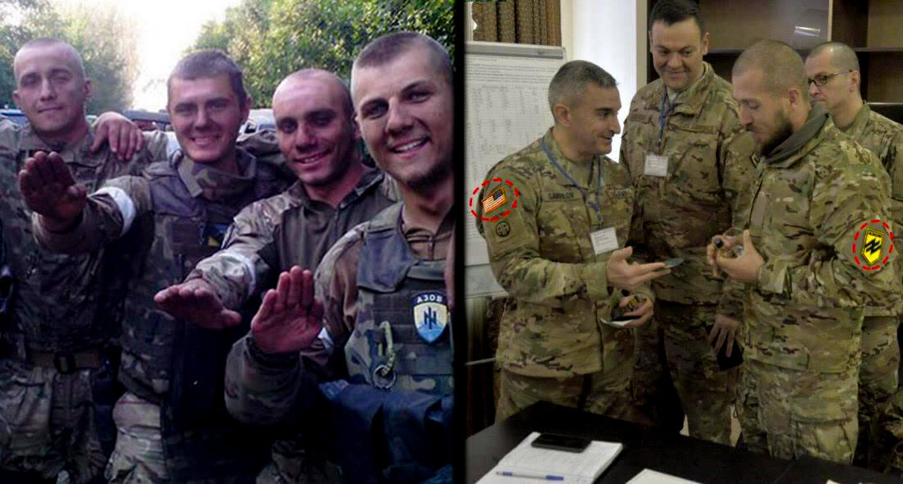
Members of the Azov Battalion display the Nazi salute, left. U.S. Army officers visit the Azov Battalion in the field, right.
By the time Congress approved a ban on arms to Azov this year, the Trump administration had already authorized a new shipment of offensive weapons to the Ukrainian military, including advanced Javelin anti-tank missiles. As in Syria — where the CIA-backed Free Syrian Army functioned as a de facto “weapons farm” for jihadist groups, including Jabhat al-Nusra and ISIS — any new U.S. arms are likely to wind up in the possession of Azov, the congressional ban notwithstanding.
“It’s very corrupt in Ukraine and money can be stolen — the same as in Syria where extremist fighters got guns from U.S.-backed units,” said Katchanovski. “Azov can just establish new political fronts so they can circumvent the U.S. prohibitions.”

Foreign fighters for fascism
The Azov Battalion has received not only U.S. weapons, but also volunteer American military veterans like Brian Boyenger. “It’s not illegal,” Boyenger told a Ukraine Today interviewer of his presence in an Azov camp. “From a U.S. perspective, as long as you’re not fighting with a terrorist group or committing war crimes or things like that. It is legal — mostly I’ve been serving as kind of like an advisor.”
Azov has also welcomed Islamist fighters from Chechnya to continue their long war against Russia in a new theater. A sniper from Sweden with “typical neo-Nazi views,” Mikael Skillt, has been assigned to oversee an entire Azov regiment. And neo-Nazis from as far away as Brazil have flocked to Ukraine to join the fascist crusade. One foreign fighter from France, a young anti-Semite named Gregoire Moutaux, returned from a Ukrainian militia camp in 2016 “armed to the teeth and ready to strike” synagogues, mosques and the 2016 soccer championships when he was arrested on the Ukrainian border by national police.
To consolidate its political influence over the country, the Azov Battalion established a National Druzhina, or street patrol unit. A slickly produced recruitment video released in 2017 featured drone footage of National Druzhina members marching in formation into Kiev as Biletsky, their ideological guide, impelled them to “restore Ukrainian order” to a corrupted society. The street patrol was openly backed by Interior Minister Arsen Avakov, a powerful patron of Azov who belongs to the ruling party of Ukrainian President Petro Poroshenko.
This year, the National Druzhina and state-funded neo-Nazi militias like C14 (the “14” represents the notorious “fourteen words” mantra)
- staged a series of lethal pogroms against the local Roma population,
- vandalized the offices of insufficiently pliant politicians,
- stormed city council meetings, and even
- sued the Hromadske station that was established with U.S. funding for describing their members as neo-Nazis.
“Their connection to power is why they can commit any crime and they will never be punished,” Katchanovski said of Azov and its various street-muscle brigades. “Because they have the police and senior police members like [Vadym] Troyan, they can intimidate people and intimidate politicians with impunity.” (Once a member of Azov, Troyan now serves as Ukraine’s Deputy Minister of Interior).
The U.S. has not only kept silent about the wave of ultra-nationalist violence sweeping across Ukraine, it has been complicit in legitimizing the perpetrators. This November, America House Kyiv — a U.S. government-funded cultural center — hosted a speech by a uniformed leader of the neo-Nazi C14 gang, Serhiy Bondar. Months earlier, Republican House Majority Leader Paul Ryan and the NATO-funded Atlantic Council hosted Andriy Parubiy, the speaker of the Ukrainian parliament and co-founder of the fascist Social-National party, for a friendly exchange on Capitol Hill.
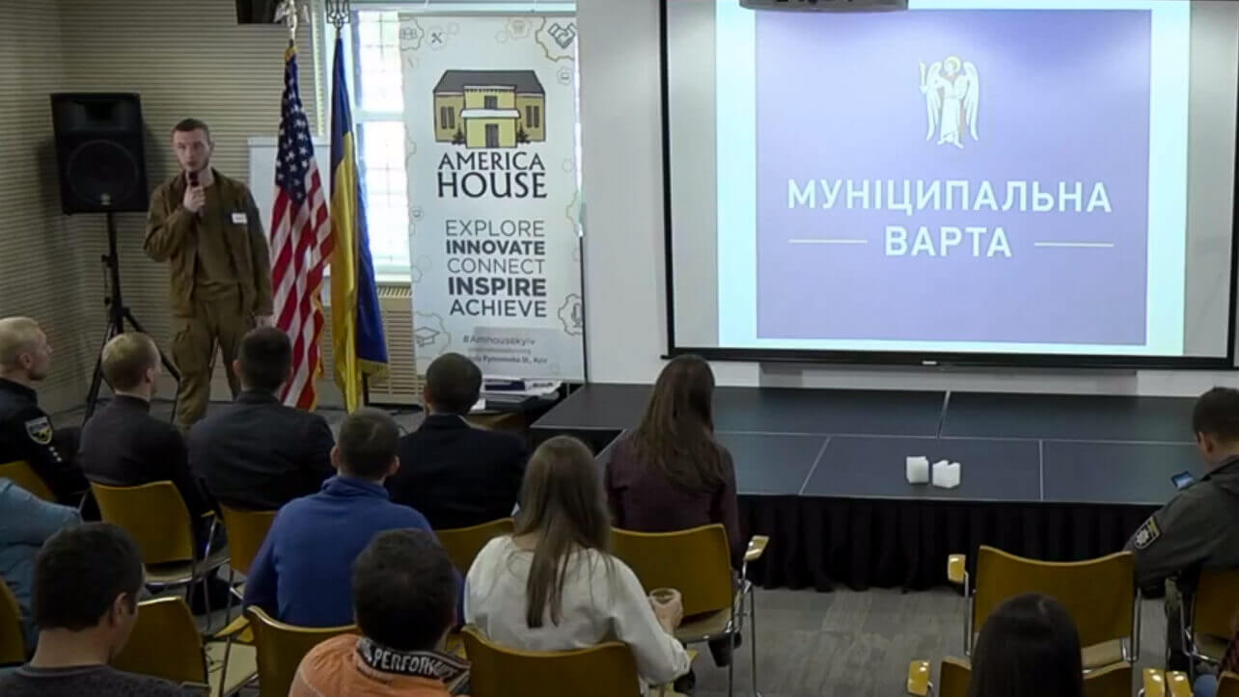
Serhiy Bondar, a member of Ukraine’s neo-Nazi C14 militia, is hosted by the U.S.-funded America House in Kiev. Screenshot | YouTube
Given the free rein and open acceptance right-wing extremists enjoy in post-Maidan Ukraine, it is no wonder the country has become a haven for fascists from across the West.

The grand Reconquista strategy
As the international secretary of Azov’s National Corps, Olena Semanyaka has emerged as one of the most prolific publicists of Eastern European fascism. With jet black hair and a faintly gothic look, she brands herself as a “traditionalist,” emulating her hero, Julius Evola, the late Italian occultist philosopher who espoused a “racism of the spirit.” Though she has been photographed bearing a Nazi flag and throwing up a sieg heil salute, Semanyaka has also been a welcome guest on Ukrainian nationalist TV to promote her campaign for the release of Ukrainian nationalist activists held by Russia.
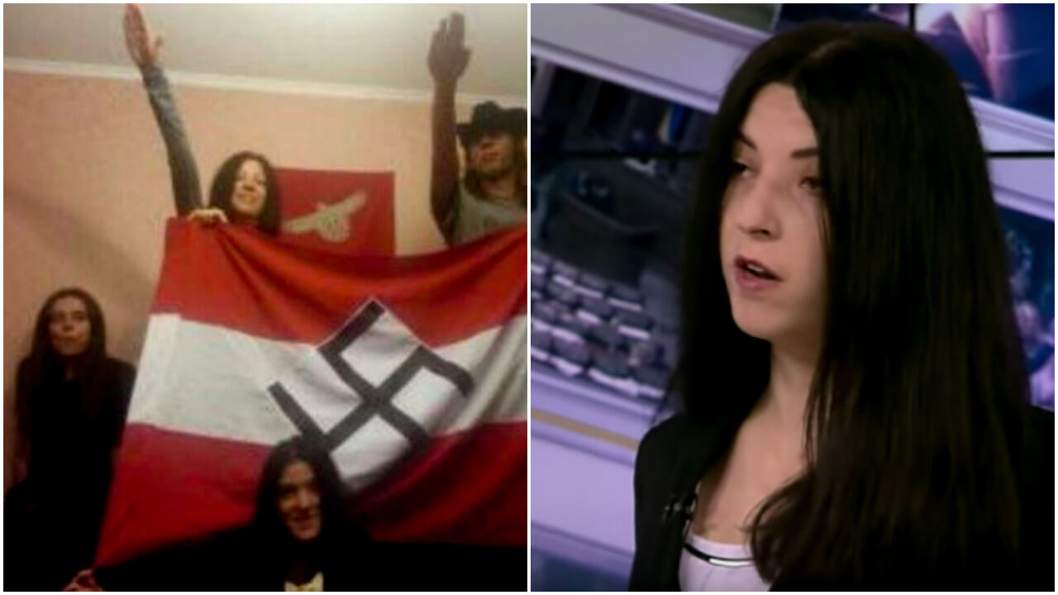
Semanya, upper left corner of Nazi flag, dispalys the Nazi salute. On the right, Semanyaka is shown during an appearance on Ukrainian state TV.
In her role with Azov, Semanyaka organizes conferences aimed at popularizing the concept of “the great European Reconquista” — a pan-European fascist-nationalist takeover that begins in the former Soviet satellite states and ultimately sweeps through Western Europe on the strength of anti-foreigner resentment.
Semanyaka laid out the fascist grand strategy in Kiev at a December 2016 gathering of Black Metal fans from across Europe called the “Pact of Steel:”
For the first time [in] a long period, the success of the Right in Western Europe — the rise of the Right because of refugee influx and terror — gives the chance for the realization of our ‘pact of steel’ between East and West, between Western and Eastern European nationalists.”
She continued:
Our main task today is to show to Western nationalists, to inform them that Putin’s Russia is no alternative to the EU of the West and that the only ally for them is an alternative axis of European integration which is being formed now in Kiev, Central and Eastern Europe, as a springboard for the all-European reconquest, for the new Europe between the EU and neo-Soviet neo-Bolshevik Putin’s Russia.”
Semanyaka and other Ukrainian fascist ideologues refer to the regional springboard for the European reconquest as the “Intermarium.” This is a concept originally envisioned after World War One by Polish military leader Jozef Pilsudski, who imagined a confederation of countries from the Baltic to the Black Sea as a counter-weight to German and Russian aggression. Though his idea never materialized, Russia’s annexation of Crimea in 2014 and the failure of the EU and NATO to prevent it revived interest in the Intermarium. One of the biggest boosters of the alliance, the right-wing Polish President Andrzej Duda, saw it primarily through the prism of regional security. The extreme right in Ukraine, however, understood the Intermarium as an ethnically pure base for exporting their revolution to the rest of Europe.
The first Intermarium conference was held in Kiev in January 2016 under the banner of Azov’s National Corps. Semanyaka headlined the event alongside Biletsky, the Azov founder, welcoming far-right activists from Poland and the Baltic States. Within a year, the concept was promoted at an officially sanctioned event at the Latvian embassy in Kiev. There, the Latvian ambassador welcomed a who’s who of the Ukrainian fascist scene, from Svoboda to National Corps representatives like Semanyaka, for a ceremony honoring Peter Radzins, a Latvian general who advocated for the Intermarium.
Organized by Latvia’s far-right National Alliance party, a member of the country’s governing coalition, the spectacle provided Azov leaders with the sheen of international legitimacy. As Matthew Kott, an academic expert on the European far-right, argued, Latvia’s “membership in the EU and NATO allows it to act as a Trojan horse for increasing the clout of the far-right in the Euro-Atlantic community.”
While historical tensions between the Intermarium nations are still simmering, Semanyaka has pleaded with her international allies to heed the call of the late pro-Hitler British Blackshirt leader Oswald Mosley for a “great act of oblivion…of all our former struggles, conflicts, historical enmity. What we need,” she argued, “is the revival of a sense of the new European aristocracy, a new European unity as a real basis for the union I am talking about.”
There are no historical grievances between American white supremacists and their cohorts in Ukraine. After all, the U.S. government has made itself the main guarantor of Ukraine’s security, going as far as directly arming Azov in its bid to bleed Russia. And decades before the U.S. backed extremists in contemporary Ukraine, the CIA ran a program to rehabilitate former Nazi collaborators from the country as anti-communist intelligence assets. Backing Ukrainian fascists is a grand American tradition, indeed.
This November, during the latest Paneuropa conference organized by Semanyaka as a safe space for fascists from across the West, she played host to one of the most prominent self-styled intellectuals of America’s white nationalist movement, Greg Johnson.
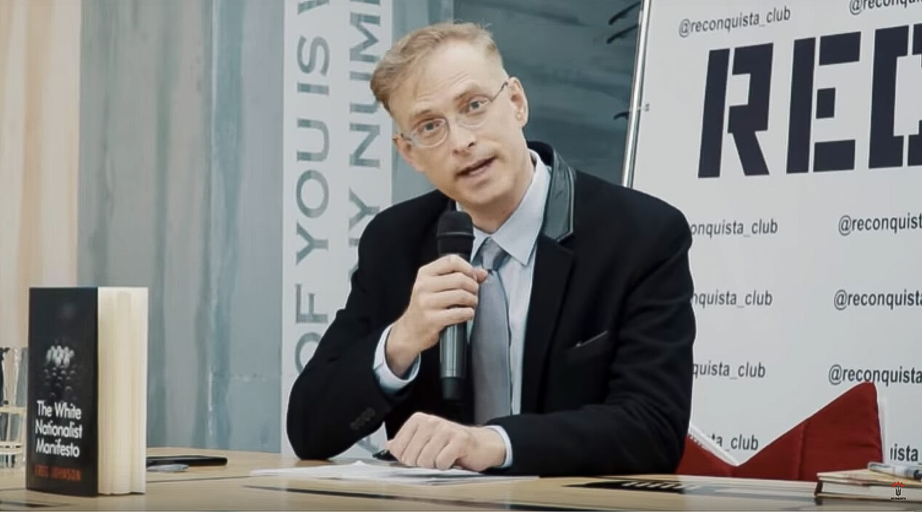
Gregory Johnson promotes his “White Nationalist Manifesto” at Azov’s Reconquista Club in Kiev, Nov. 2018. Screenshot | YouTube
“I think that what’s happening in Ukraine is a model and an inspiration for nationalists of all white nations and I wanted to learn as much as possible about what you’re doing here and see as much as possible,” Johnson told his rapt audience. “And I’m enormously impressed and I’m taking notes.”
Johnson is a highbrow racist who publishes a journal, Counter-Currents, that advances what he calls “white identity politics.” Like the Rise Above Movement leaders before him, he was clearly inspired by his visit to Kiev. “I’m already planning to come back,” Johnson exclaimed during a break-out session. “I’m very impressed with what I’ve seen here. I want to come back and learn more.”

APPENDIX
Svoboda Party: Originally called the Social-National Party of Ukraine, a Ukrainian political party with long history of anti-Semitism. Led by Oleh Tyahnybok, Svoboda played a prominent role in the 2013-2014 Maidan uprising, where Tyahnybok shared the stage with U.S. Senators John McCain (R-AZ) and Chris Murphy (D-CT). Andriy Parubiy, who had co-founded the Social-National Party of Ukraine, is now Speaker of Parliament.
Azov Battalion: 3,000-member neo-Nazi formation in Ukraine’s National Guard. Azov began as a paramilitary, originally formed out of the Patriot of Ukraine neo-Nazi gang led by Andriy Biletsky, and is now a Ukrainian National Guard unit. The battalion’s logo incorporates the neo-Nazi Wolfsangel and black sun symbols. Biletsky is now a member of Ukrainian Parliament. Vadim Troyan, another Azov veteran, is now Deputy Interior Minister.
Ukrainian National Corps: Azov’s civilian arm, responsible, among other things, for coordinating with and recruiting neo-Nazis and white supremacists from around the world. The international outreach is led by Olena Semanyka, who’s been photographed with a swastika flag.
National Druzhina: Azov’s street patrol organization, established in January 2018 with the aim of “restoring Ukrainian order” to the streets. The National Druzhina — whose members pledge personal loyalty to Biletsky — has been involved in pogroms against the Roma, LGBT, and other activists.
Right Sector: Loose formation of neo-Nazis and football ultras, which supplied street muscle to the 2013-2014 Maidan uprising. Later involved in lethal suppression of anti-Maidan movements in places like Odessa.
C14: Ukrainian neo-Nazi gang that receives government funding and has been responsible for some of the lethal Roma pogroms as well as anti-LGBT violence. The 14 is a reference to the Fourteen Word slogan of white supremacy. Led by Serhiy Bondar, who spoke at America House, a cultural center funded by the U.S. government.

Top Photo | Volunteers of the Azov Battalion carry portraits of members killed in the war conflict with separatists in the country’s east, at a rally marking Fatherland Defender Day in Kiev, Ukraine, Oct. 14, 2016. Efrem Lukatsky | AP
Max Blumenthal is the founder and editor of GrayzoneProject.com, the co-host of the podcast Moderate Rebels, the author of several books, and producer of full-length documentaries including the recently released Killing Gaza. Follow him on Twitter at @MaxBlumenthal.

Republish our stories! MintPress News is licensed under a Creative Commons Attribution-NonCommercial-ShareAlike 3.0 International License.

